HONORS CHEMISTRY • UNIT 2
Electrons & Periodic Trends
The arrangement of electrons explains the shape of the periodic table, why elements react the way they do, and every trend you will use for the rest of the course.

TEACHER EDITION
Everything in a light-gray box or cell is an answer or model response. Teacher notes (misconceptions, demo ideas, discussion prompts, sources) appear in the heavy-bordered boxes labeled TEACHER NOTE. The pages follow the student packet, so they line up closely.

What we will learn
2.1 | Bohr models & Lewis dot structures
2.2 | The quantum mechanical model & electron configuration
2.3 | Orbital diagrams (Aufbau, Pauli & Hund)
2.4 | Periodic trends: ionization energy & atomic radius
2.5 | Periodic trends: electronegativity & successive ionization energy
★ | Extra practice & unit review

By the end of this unit I can…
• Explain how Bohr’s model improved on Rutherford’s, and use line spectra and flame tests as evidence for energy levels.
• Draw Bohr models and Lewis dot structures and find valence electrons from a periodic table.
• Write full and noble-gas shorthand electron configurations for atoms and ions.
• Draw orbital diagrams that obey the Aufbau principle, the Pauli exclusion principle and Hund’s rule.
• Use Coulomb’s law (nuclear charge, distance and shielding) to explain trends in ionization energy and atomic radius.
• Explain the trend in electronegativity and use successive ionization energies to identify an element’s group.
• Rank atoms and ions in order of radius, ionization energy and electronegativity and justify each ranking.
Unit at a glance (teacher)
Topic | Suggested pacing | Depth the homework expects
2.1 Bohr & Lewis | 1–2 days | Bohr’s improvement over Rutherford; Bohr models (Na, C, Ar, Al, O, K); valence electrons; Lewis dots; identify elements from clues.
2.2 Configuration | 2 days | Full and shorthand configurations (Be, Mg, Ca, N, Cl, Mn, Cd, Sr, As, S, Al); identify the element; spot illegal configurations.
2.3 Orbital diagrams | 1–2 days | Orbital diagrams with Hund’s rule and Pauli; unpaired electrons; ions.
2.4 IE & radius | 2 days | Written explanations with Coulomb’s law (period and group); Bohr models of Li and Na; ranking lists; larger-atom pairs.
2.5 EN & successive IE | 1–2 days | Word bank fill-in; ranking radius and EN; F vs I ionization energy; why families behave similarly; left-to-right trends.

TEACHER OVERVIEW
Big picture. The homework asks students to explain trends “using principles of atomic structure and Coulomb’s law,” so every trend in this packet is built on three words: nuclear charge, distance, shielding. Insist that students name all three that apply.
Misconceptions to watch for:
• Electrons orbit the nucleus like planets (the quantum model has probability clouds).
• Electrons in the same shell shield each other well (they don’t, which is why Zeff rises across a period).
• “Atoms get bigger across a period because they have more electrons.” (Shells stay the same; the pull gets stronger.)
• Writing 3d before 4s when asked for the ground-state filling order (accept either in final answers if the electron count is right; the homework uses energy order).
• Confusing 1s² (superscript = electrons) with 1s₂.
• Putting a second electron into an orbital before every orbital of the sublevel has one (Hund’s rule).

IMAGES
Image spots: figures from the homework (Bohr diagrams of Li and Na, the periodic table pages) fit in the framed IMAGE GOES HERE boxes. Everything else is drawn to print in black and white.

TOPIC  2.1 | Bohr Models & Lewis Dot Structures  Energy levels • line spectra • valence electrons

BIG IDEA
Bohr proposed that electrons can only exist in certain energy levels (shells) around the nucleus, like steps on a staircase. Electrons jump between levels by absorbing or emitting exactly the right amount of energy.

Key vocabulary — write each definition in your own words
Term | Definition (your words) | Example / sketch
Energy level (shell) | A region around the nucleus where electrons of a certain energy are found. Level 1 holds up to 2 e⁻, level 2 up to 8, level 3 up to 8 (for the first 20 elements). | Na: 2, 8, 1
Valence electron | An electron in the outermost energy level. These are the electrons that are lost, gained or shared in chemical reactions. | Chlorine has 7 valence electrons.
Core electron | An electron in an inner energy level. Core electrons are held tightly and do not take part in bonding. | Na has 10 core e⁻ and 1 valence e⁻.
Emission spectrum | The set of specific wavelengths of light an element gives off when its excited electrons fall back to lower energy levels. Every element has its own pattern. | Hydrogen’s lines at 410, 434, 486 and 656 nm.
Lewis dot structure | A diagram showing an element’s symbol surrounded by dots, one dot for each valence electron. | Magnesium: Mg with 2 dots.

How did Bohr improve Rutherford’s model?
CUES / KEY WORDS  Rutherford  Bohr  Evidence | COMPARE THE TWO MODELS  Rutherford: a tiny dense nucleus with electrons somewhere outside it, but no rule for where; a moving electron should lose energy and spiral into the nucleus.  Bohr: electrons move only in specific energy levels (shells) at set distances; they don’t lose energy while in a level; they absorb or emit energy only when jumping between levels.  Evidence: element line spectra: if energy were not quantized atoms would give off a continuous rainbow, not separate lines.

THINK OF IT LIKE… A STAIRCASE
On a staircase you can stand on step 1 or step 2, but never in between. Electrons are the same: they can only be at certain energy levels. Moving up a step takes a specific amount of energy; moving down releases the same amount, as light.

LAB CORNER • Line spectra: the fingerprint of an element

When hydrogen gas is heated or energized, it glows. A prism or diffraction grating spreads that light into a spectrum.
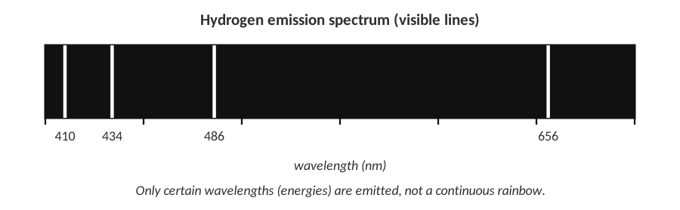 | 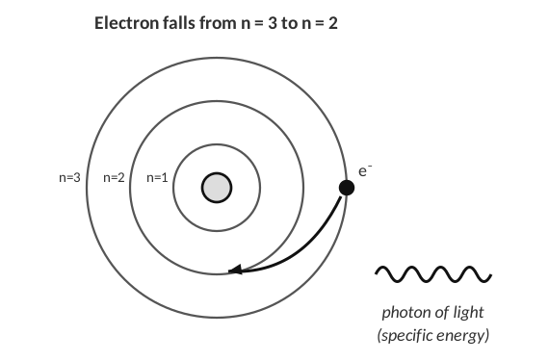
Visible lines in the hydrogen spectrum | An electron falls to a lower level

1. Why does hydrogen emit only a few separate lines and not a continuous rainbow of colors?
Hydrogen’s electron can only be in certain energy levels. When it falls from a higher level to a lower one it releases a photon with exactly the energy difference between those levels, so only certain wavelengths of light are produced.

2. The line at 410 nm has a shorter wavelength than the line at 656 nm. Which line comes from the larger energy drop? Explain.
The 410 nm line. Shorter wavelength means higher-energy light, so the electron fell through a larger energy gap.

3. What happens to an electron when an atom absorbs energy? What happens when it falls back?
Absorbing energy moves the electron to a higher energy level (excited state). When it falls back to a lower level it gives off the energy as light.

LAB CORNER • Flame tests

A student dips a clean wire loop into solutions of metal salts and holds it in a Bunsen burner flame. Each metal ion produces a different flame color.
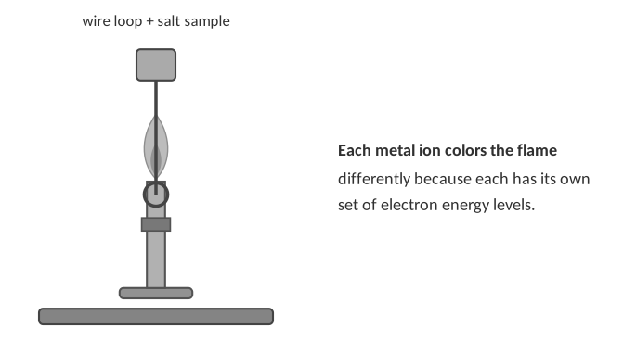
Metal ion in the salt | Flame color observed
Lithium (Li⁺) | crimson red
Sodium (Na⁺) | bright yellow-orange
Potassium (K⁺) | pale lilac / violet
Calcium (Ca²⁺) | orange-red
Copper (Cu²⁺) | blue-green
Barium (Ba²⁺) | yellow-green

4. Explain, using electron energy levels, where the colored light in a flame test comes from and why each metal gives a different color.
The heat excites the metal’s electrons to higher energy levels. When they fall back down they emit photons whose energies equal the gaps between levels. Each element has different energy levels, so each emits different wavelengths, which we see as different colors.

5. A student tests a white powder and sees a bright yellow-orange flame. What metal ion is most likely in the powder? Why isn’t flame color alone enough to be certain when the flame is orange-red?
Sodium (Na⁺). Several metals (for example calcium and strontium) give similar red-orange flames that are hard to tell apart by eye, so a spectroscope (which shows each line separately) or other tests are needed.

TEACHER NOTE
Safety: wear goggles; use a wooden splint soaked in water or a nichrome wire cleaned in HCl. Sodium contamination makes every flame orange, which makes a good “why did my results look wrong?” discussion. Neon signs and fireworks are everyday uses of the same idea.

Drawing Bohr models
BOHR MODEL RULES
• The number in the nucleus = atomic number (protons).
• Fill the shells closest to the nucleus first: 2 → 8 → 8 … (up to element 20).
• The electrons in the last shell are the valence electrons.

Draw the Bohr model for each element. Write the number of protons in the nucleus and place dots for electrons on the rings.
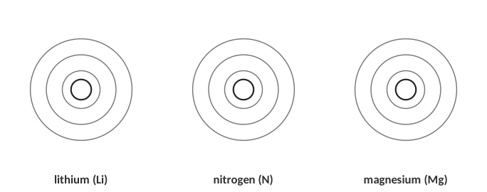
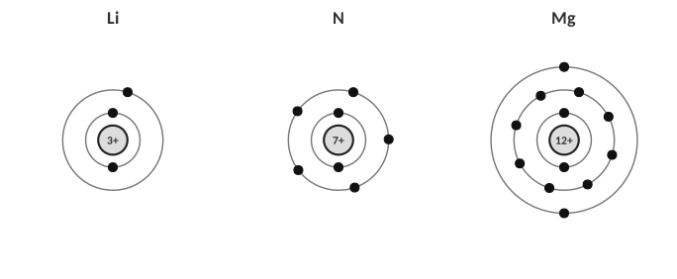
Answers: Li 2-1, N 2-5, Mg 2-8-2
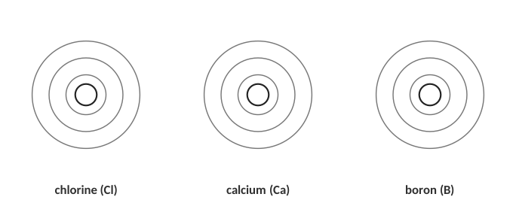
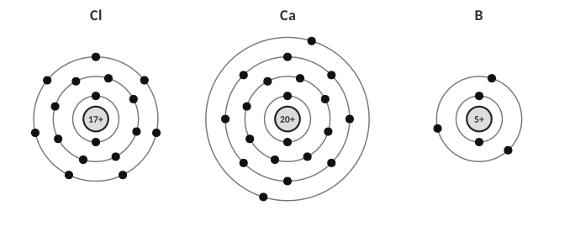
Answers: Cl 2-8-7, Ca 2-8-8-2, B 2-3
6. How do you find the number of valence electrons for an element using the periodic table?
For main-group elements, the group number tells you: groups 1 and 2 have 1 and 2 valence electrons; for groups 13–18 subtract 10 from the group number (group 15 → 5, group 17 → 7). Helium is the exception (group 18, but only 2). You can also count the electrons in the outermost shell of the Bohr model.

Group | 1 | 2 | 13 | 14 | 15 | 16 | 17 | 18
Valence electrons | 1 | 2 | 3 | 4 | 5 | 6 | 7 | 8 (He: 2)

Lewis dot structures
THINK OF IT LIKE… SEATS ON A SQUARE TABLE
Put one dot on each side of the symbol (top, right, bottom, left) before you pair any up. This is like people sitting at a square table: everyone takes their own side first.

Draw the Lewis dot structure for each element.
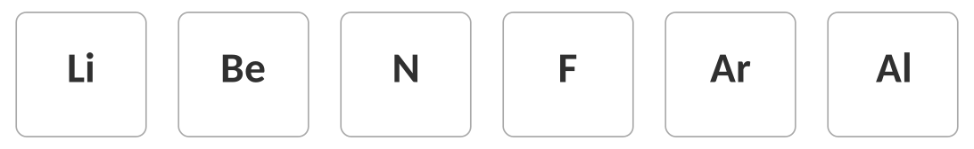

Answers
Identify the element
Clue | Element
Has 5 valence electrons and is in period 3. | phosphorus (P)
Has 7 valence electrons and its most abundant isotope has 18 neutrons. | chlorine (Cl-35: 17 p⁺ + 18 n⁰)
Has 8 valence electrons and is in period 2. | neon (Ne)
Has a Bohr model with 2, 8, 2 electrons in its shells. | magnesium (Mg)

WATCH OUT!
Valence electrons are counted by the outermost shell, not by the total number of electrons. Sodium has 11 electrons but only 1 valence electron.

[ IMAGE GOES HERE ]
Optional: Bohr model diagrams from your Topic 2.1 homework (identify the elements)

7. An electron in an atom absorbs energy. What happens next?
A) It moves to a lower energy level.
B) It moves to a higher energy level.
C) It leaves the nucleus.
D) It becomes a proton.

TOPIC  2.2 | The Quantum Mechanical Model & Electron Configuration  Sublevels • orbitals • Aufbau order

BIG IDEA
Electrons don’t circle the nucleus like planets. They occupy orbitals, 3-D regions where an electron is most likely to be found. Orbitals are grouped into sublevels (s, p, d, f) inside each energy level. An electron configuration lists where every electron is.

Key vocabulary — write each definition in your own words
Term | Definition (your words) | Example / sketch
Orbital | A region of space where there is a high probability of finding an electron. Each orbital holds a maximum of 2 electrons. | The 2p sublevel has three orbitals.
Sublevel (s, p, d, f) | A group of orbitals of the same shape and similar energy inside an energy level. s has 1 orbital (2 e⁻), p has 3 (6 e⁻), d has 5 (10 e⁻), f has 7 (14 e⁻). | Energy level 3 has 3s, 3p and 3d.
Electron configuration | A shorthand that shows which energy levels and sublevels hold electrons. The big number is the energy level, the letter the sublevel, the superscript the number of electrons. | O: 1s² 2s² 2p⁴
Aufbau principle | Electrons fill the lowest-energy sublevel available before moving to a higher one (1s, 2s, 2p, 3s, 3p, 4s, 3d …). | 4s fills before 3d.
Noble gas shorthand | A short way to write a configuration: put the symbol of the previous noble gas in brackets to stand for all the inner electrons, then write the rest. | Na: [Ne] 3s¹

THINK OF IT LIKE… AN APARTMENT BUILDING
The energy level is the floor of the building (n = 1, 2, 3 …). Each floor has different types of rooms (s, p, d, f). Each room is an orbital, and every room holds at most 2 people. People take the cheapest, lowest rooms first, and the building gets bigger as you go up (floor 1 has just an s room; floor 3 has s, p and d rooms).

Sublevel | Shape | Number of orbitals | Max electrons
s | sphere | 1 | 2
p | dumbbell | 3 | 6
d | clover-leaf (mostly) | 5 | 10
f | complex | 7 | 14

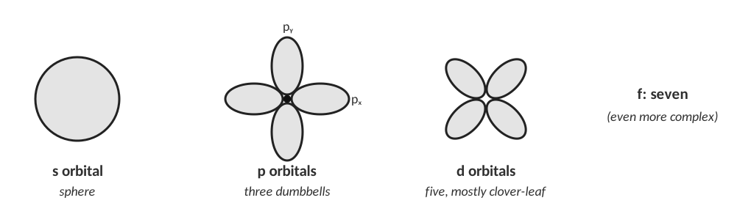
Orbital shapes (not to scale).
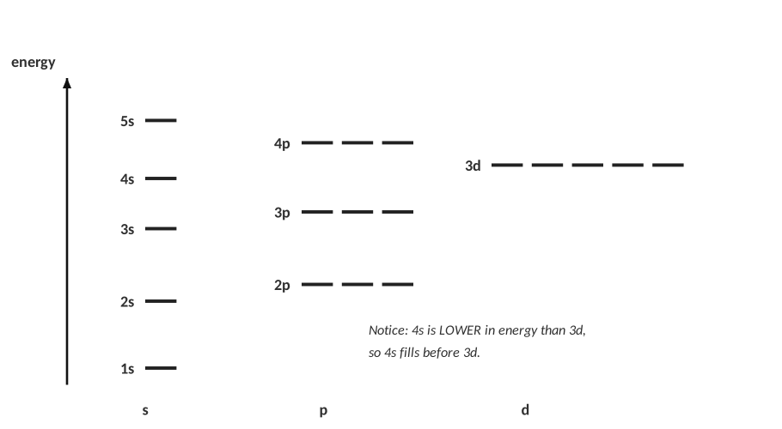
Relative energies of the sublevels.
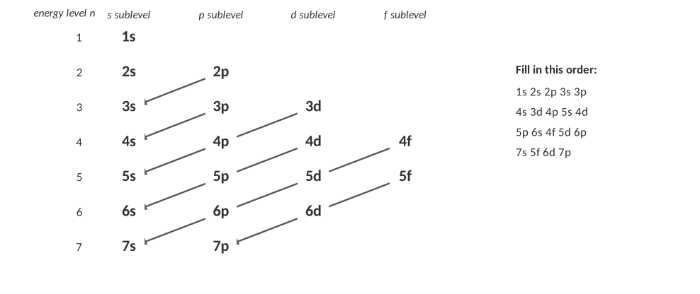
The diagonal rule: follow each arrow from top right to bottom left.
CUES / KEY WORDS  Aufbau  Order | WRITE THE FILLING ORDER FROM MEMORY (USE THE DIAGRAM AS A GUIDE)  1s, 2s, 2p, 3s, 3p, 4s, 3d, 4p, 5s, 4d, 5p, 6s, 4f, 5d, 6p, 7s …

The periodic table is a map of the filling order
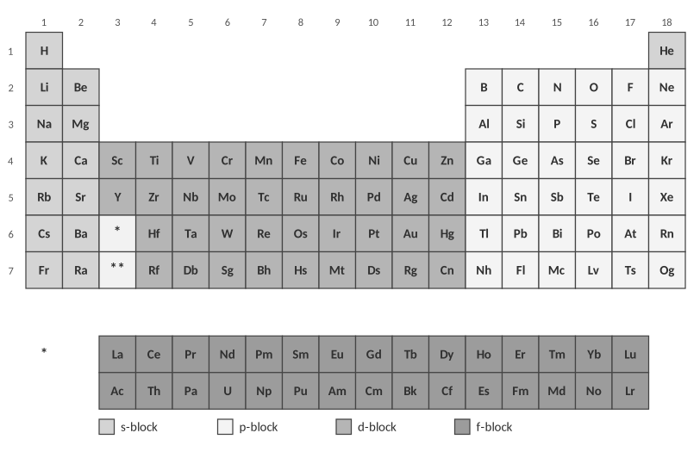
Blocks of the periodic table.
1. Use the table above to explain why the periodic table has a block of 2 columns on the left, 6 on the right, and 10 in the middle.
The widths match the maximum number of electrons each sublevel holds: s = 2, p = 6, d = 10 (and f = 14 in the rows pulled out below). The table’s shape comes from filling order.

Worked examples
WORKED EXAMPLE — FULL CONFIGURATION
Write the electron configuration for nitrogen (7 electrons).

1. Fill 1s: 2 electrons (5 left).
2. Fill 2s: 2 electrons (3 left).
3. Put the last 3 electrons in 2p.
1s² 2s² 2p³ Check: 2 + 2 + 3 = 7 ✓

Answer: 1s² 2s² 2p³
WORKED EXAMPLE — SHORTHAND
Write the noble gas shorthand for arsenic (As, 33 electrons).

The previous noble gas is argon (18 e⁻), so start with [Ar].
The remaining 15 electrons fill, in order: 4s² (2), 3d¹⁰ (10), 4p³ (3).
[Ar] 4s² 3d¹⁰ 4p³

Answer: [Ar] 4s² 3d¹⁰ 4p³
WORKED EXAMPLE — IDENTIFY FROM THE CONFIGURATION
Which element has the configuration 1s² 2s² 2p⁶ 3s² 3p⁴?

Add the superscripts: 2 + 2 + 6 + 2 + 4 = 16 electrons. A neutral atom has 16 protons: sulfur (S).
Valence electrons: the 3rd energy level has 2 + 4 = 6.

Answer: sulfur (S)
QUICK TRICKS
• The period number is the highest energy level (n) in the configuration.
• Valence electrons = electrons in the highest energy level (the s and p electrons of the outer shell).
• Superscripts always add up to the atomic number (for a neutral atom).

Practice: write the full configuration, then circle the valence electrons
Element | Electron configuration | Valence e⁻
Be (Z = 4) | 1s² 2s² | 2
Mg (Z = 12) | 1s² 2s² 2p⁶ 3s² | 2
Ca (Z = 20) | 1s² 2s² 2p⁶ 3s² 3p⁶ 4s² | 2

2. What do the configurations of Be, Mg and Ca have in common? Why does this make sense?
Their outermost electrons are all ns² (2s², 3s², 4s²). They are in the same group (2) and have the same number of valence electrons, so they behave similarly.

Element | Electron configuration | Valence e⁻
N (Z = 7) | 1s² 2s² 2p³ | 5
Cl (Z = 17) | 1s² 2s² 2p⁶ 3s² 3p⁵ | 7
Mn (Z = 25) | 1s² 2s² 2p⁶ 3s² 3p⁶ 4s² 3d⁵ | 2
Cd (Z = 48) | 1s² 2s² 2p⁶ 3s² 3p⁶ 4s² 3d¹⁰ 4p⁶ 5s² 4d¹⁰ | 2

TEACHER NOTE
Mn is [Ar] 4s² 3d⁵ and Cd is [Kr] 5s² 4d¹⁰ in the energy-ordered form the homework uses. Some courses write the d before the s ([Ar] 3d⁵ 4s²); accept both when the electron counts are right. Valence electrons for transition metals are usually counted as the ns electrons (2 for Mn and Cd) in this course.

Practice: noble gas shorthand
Element | Shorthand configuration
Sr (Z = 38) | [Kr] 5s²
As (Z = 33) | [Ar] 4s² 3d¹⁰ 4p³
S (Z = 16) | [Ne] 3s² 3p⁴
Al (Z = 13) | [Ne] 3s² 3p¹

Practice: identify the element
Configuration | Element
1s² 2s² 2p⁶ 3s¹ | sodium (Na)
[Kr] 5s² 4d¹⁰ 5p³ | antimony (Sb)
1s² 2s² 2p⁶ 3s² 3p⁶ 4s² 3d¹⁰ 4p⁶ 5s² 4d¹⁰ 5p³ | antimony (Sb) (51 electrons)
[Ne] 3s² 3p² | silicon (Si)

Find the error
Each configuration below is for a neutral atom. Is it correct? If not, explain what is wrong and write the correct one.
Configuration | Correct? If not, fix it
1s² 2s² 2p⁶ 3s³ | No. The 3s sublevel holds only 2 electrons. Na is 1s² 2s² 2p⁶ 3s¹.
1s² 2s² 2p⁷ | No. The p sublevel holds a maximum of 6 electrons. For 11 electrons: 1s² 2s² 2p⁶ 3s¹.
1s² 2s¹ 2p⁵ | No. 2s must fill before 2p (Aufbau). Fluorine is 1s² 2s² 2p⁵. (This one is an excited state.)
[Ar] 4s² 3d¹⁰ 4p⁵ | Yes — bromine (35 electrons).
[Ar] 5s² 4d¹⁰ 5p⁵ | No. The core must be [Kr] (36 e⁻) for 5s, 4d, 5p: iodine is [Kr] 5s² 4d¹⁰ 5p⁵.

Configurations of ions
CUES / KEY WORDS  Cations  Anions  Isoelectronic | HOW DO YOU WRITE THE CONFIGURATION OF AN ION?  Cation (positive): remove electrons from the highest energy level first: Na [Ne]3s¹ → Na⁺ [Ne]. For transition metals remove the 4s electrons before 3d.  Anion (negative): add electrons to the next open spots: O 2p⁴ → O²⁻ 2p⁶.  Isoelectronic species have the same electron configuration: Na⁺, Ne and F⁻ are all 1s² 2s² 2p⁶.

Ion | Configuration | Same configuration as which noble gas?
Na⁺ | 1s² 2s² 2p⁶ | Ne
O²⁻ | 1s² 2s² 2p⁶ | Ne
Mg²⁺ | 1s² 2s² 2p⁶ | Ne
Cl⁻ | 1s² 2s² 2p⁶ 3s² 3p⁶ | Ar
Ca²⁺ | 1s² 2s² 2p⁶ 3s² 3p⁶ | Ar
Al³⁺ | 1s² 2s² 2p⁶ | Ne

REAL WORLD
Atoms “want” a filled outer shell like a noble gas. That is why sodium readily forms Na⁺ and chlorine forms Cl⁻: they end up with the same stable configuration as neon and argon. This is the whole story of ionic bonding (Unit 9).

TEACHER NOTE
Extension (exceptions): chromium is [Ar] 4s¹ 3d⁵ and copper is [Ar] 4s¹ 3d¹⁰ because half-filled and completely filled d sublevels are especially stable. The homework doesn’t require this; mention it for AP-bound students.

3. How many electrons can the 3d sublevel hold?
A) 2
B) 6
C) 10
D) 14

4. Which is the correct shorthand configuration for calcium?
A) [Ne] 3s²
B) [Ar] 4s²
C) [Ar] 3d²
D) [Kr] 4s²

TOPIC  2.3 | Orbital Diagrams  Aufbau • Pauli exclusion • Hund’s rule

BIG IDEA
An orbital diagram shows every orbital as a box and every electron as an arrow. It tells you more than a configuration: it shows which electrons are paired and which are unpaired, and that decides how an atom behaves in a magnetic field and in bonding.

Key vocabulary — write each definition in your own words
Term | Definition (your words) | Example / sketch
Orbital | A region of space around the nucleus (drawn as one box) where an electron is likely to be found. Each orbital holds a maximum of 2 electrons. | The 2p sublevel has three orbitals.
Pauli exclusion principle | No two electrons in an atom can have the same set of quantum numbers. In one orbital the two electrons must have opposite spins (one arrow up, one arrow down). | ↑↓ is allowed; ↑↑ in one box is not.
Hund’s rule | Electrons occupy the orbitals of a sublevel one at a time, all with the same spin, before any orbital gets a second electron. | N: 2p has ↑ ↑ ↑, not ↑↓ ↑ _
Paired / unpaired electron | A paired electron shares a box with an electron of opposite spin; an unpaired electron is alone in its box. | Carbon has 2 unpaired electrons.
Degenerate orbitals | Orbitals that have exactly the same energy, such as the three 2p orbitals. | 2px, 2py, 2pz

THINK OF IT LIKE… SEATS ON A BUS
Strangers boarding a bus take an empty double-seat to themselves before sitting next to someone (Hund’s rule). Only when every double-seat has one person does anyone sit beside a stranger. Each seat holds at most two people, and they must be facing opposite directions (Pauli). Passengers fill the front rows first (Aufbau).

The three rules — write each one in your own words
CUES / KEY WORDS  Aufbau principle  Pauli exclusion principle  Hund’s rule | STATE EACH RULE AND SKETCH A SMALL EXAMPLE  Aufbau: fill the lowest-energy sublevel first (1s, 2s, 2p, 3s …).  Pauli: at most 2 electrons per orbital and they must have opposite spins (↑↓).  Hund: put one electron in each orbital of a sublevel (all spinning the same way) before pairing any up. Example: 2p³ = ↑ ↑ ↑.

How to draw an orbital diagram
STEPS
1. Write the electron configuration first (so you know how many electrons go in each sublevel).
2. Draw boxes: 1 box for s, 3 for p, 5 for d, 7 for f.
3. Add arrows one at a time, ↑ first in every box of the sublevel (Hund), then add ↓ to pair them.
4. Check: the total number of arrows equals the atomic number, and no box holds more than two arrows.

WORKED EXAMPLE — NITROGEN
Draw the orbital diagram for nitrogen (Z = 7).

1s² 2s² 2p³. Fill 1s and 2s with paired arrows. The three 2p electrons go in three different boxes, all pointing up.
Unpaired electrons = 3.

Answer: see diagram
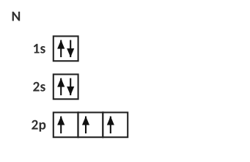
Nitrogen: three unpaired electrons.
WORKED EXAMPLE — IRON
Draw the orbital diagram for iron (Z = 26) and count its unpaired electrons.

Configuration: 1s² 2s² 2p⁶ 3s² 3p⁶ 4s² 3d⁶. The six 3d electrons: first five go in separate boxes (↑ ↑ ↑ ↑ ↑), the sixth pairs with the first box.
Unpaired electrons = 4.

Answer: 4 unpaired
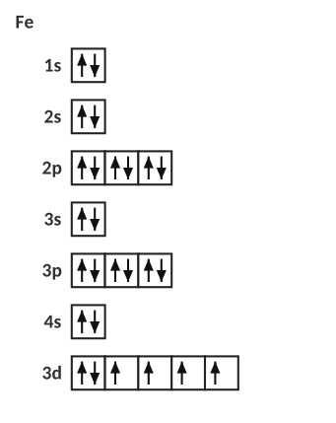
Iron: four unpaired electrons in 3d.
Practice: complete the orbital diagram
Fill in the arrows. Then write the number of unpaired electrons.
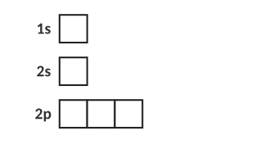
O (Z = 8): unpaired electrons = ________
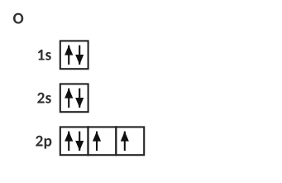
Answer: O, 2 unpaired
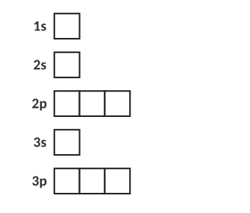
P (Z = 15): unpaired electrons = ________
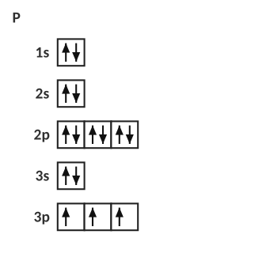
Answer: P, 3 unpaired
Find the error
Each diagram below is meant to show nitrogen’s outer electrons (2s and 2p). Only one is correct. For the other two, name the rule that is broken.
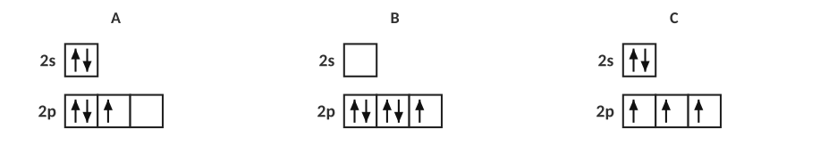
1. Which diagram is correct, and what rule is broken in each of the others?
C is correct. A breaks Hund’s rule (two electrons paired in one 2p box while another 2p box is empty). B breaks the Aufbau principle (2s is empty while higher-energy 2p holds five electrons).

Unpaired electrons across period 3
Element | Shorthand configuration | Unpaired e⁻ | Attracted to a magnet?
Na | [Ne] 3s¹ | 1 | yes
Mg | [Ne] 3s² | 0 | no
Al | [Ne] 3s² 3p¹ | 1 | yes
Si | [Ne] 3s² 3p² | 2 | yes
P | [Ne] 3s² 3p³ | 3 | yes
S | [Ne] 3s² 3p⁴ | 2 | yes
Cl | [Ne] 3s² 3p⁵ | 1 | yes
Ar | [Ne] 3s² 3p⁶ | 0 | no

2. Describe the pattern in the number of unpaired electrons as you move across period 3. Why does it go up and then back down?
Na 1, Mg 0, Al 1, Si 2, P 3, then S 2, Cl 1, Ar 0. The 3p orbitals each get one electron first (Hund’s rule) up to phosphorus; after that every new electron has to pair up with one already there, so the number of unpaired electrons falls.

TEACHER NOTE — UNPAIRED ELECTRONS
Period 3 unpaired electrons: Na 1, Mg 0, Al 1, Si 2, P 3, S 2, Cl 1, Ar 0. A student answer that says “it increases to 3 and decreases to 0” is correct; the dip at Mg (0) is a good prompt about full s sublevels. Paramagnetic = at least one unpaired electron; diamagnetic = none. Fun demo: liquid oxygen is attracted to a strong magnet (O₂ has two unpaired electrons) — show a video if available.

Orbital diagrams for ions
3. Draw the 2p orbital boxes for O (2p⁴) and for O²⁻. How many unpaired electrons does each have? Why is O²⁻ stable?
O: ↑↓ ↑ ↑ (2 unpaired). O²⁻ (2p⁶): ↑↓ ↑↓ ↑↓ (0 unpaired). The 2p sublevel is full, giving the same stable arrangement as neon.

4. Write the electron configuration and count the unpaired electrons for Fe²⁺ and Fe³⁺. (Remove the 4s electrons first.)
Fe²⁺: 1s² 2s² 2p⁶ 3s² 3p⁶ 3d⁶ → 4 unpaired. Fe³⁺: 1s² 2s² 2p⁶ 3s² 3p⁶ 3d⁵ → 5 unpaired (3d⁵, a half-filled sublevel).

Extension: photoelectron spectroscopy (PES) as evidence for sublevels
In PES a sample is hit with high-energy light and the energy needed to remove each electron is measured. Each peak is one sublevel; the height is the number of electrons in it. Peaks farther left need more energy (those electrons are closest to the nucleus).
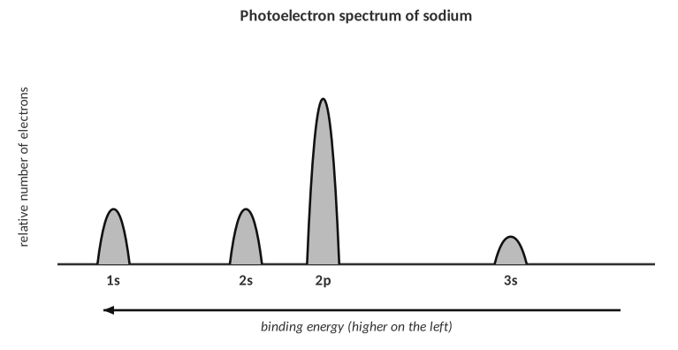
5. The PES for an unknown element shows three peaks with relative heights 2 : 2 : 1 (left to right). Which element is it? Write its configuration.
Total electrons = 2 + 2 + 1 = 5, so boron: 1s² 2s² 2p¹.

6. In the sodium spectrum, why is the 1s peak farthest to the left?
1s electrons are closest to the nucleus and feel the strongest effective nuclear charge, so they have the greatest binding energy.

7. How many unpaired electrons does a ground-state atom of sulfur have?
A) 0
B) 1
C) 2
D) 4

8. Which rule is broken if two electrons in the same orbital both point up?
A) Aufbau
B) Hund
C) Pauli exclusion
D) Dalton

9. Which element has exactly three unpaired electrons?
A) Si
B) P
C) S
D) Cl

TOPIC  2.4 | Periodic Trends I: Ionization Energy & Atomic Radius  Coulomb’s law • nuclear charge • distance • shielding

BIG IDEA
Almost every periodic trend comes from one idea: opposite charges attract. The nucleus (+) pulls on the electrons (−). How hard it pulls depends on how many protons, how far away the electron is, and how many other electrons are in the way.

Key vocabulary — write each definition in your own words
Term | Definition (your words) | Example / sketch
Atomic radius | The size of an atom, usually half the distance between the nuclei of two bonded atoms. Measured in picometres (pm). | Na ≈ 186 pm; Cl ≈ 100 pm
Ionization energy (IE) | The energy required to remove the outermost electron from a gaseous atom: X(g) → X⁺(g) + e⁻. It is always positive (it costs energy). | Na: 496 kJ/mol
Effective nuclear charge (Zeff) | The net positive charge an outer electron actually feels: the nuclear charge minus the shielding from inner electrons. Roughly, Zeff ≈ protons − core electrons. | Na: +11 − 10 core e⁻ ≈ +1
Shielding | The blocking of the nucleus’s pull on outer electrons by the inner (core) electrons between them. | The 1s and 2 shell electrons shield Na’s 3s electron.
Coulomb’s law | The force of attraction between charges increases with the size of the charges and decreases rapidly as the distance between them increases: F = k(q₁q₂)/r². | Doubling the distance cuts the force to ¼.

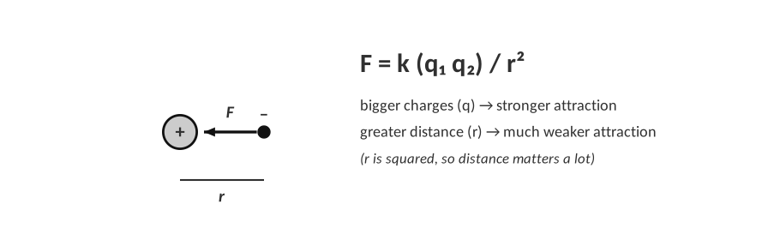
Coulomb’s law: the pull on an electron.
THINK OF IT LIKE… A MAGNET AND A PAPERCLIP
A paperclip held close to a magnet jumps to it. Move it a little farther away and the pull almost disappears (distance). Use a stronger magnet and the pull grows (nuclear charge). Put a thick book between them and the pull is weakened (shielding). An outer electron feels the nucleus exactly like that paperclip.

The three factors — your own words
CUES / KEY WORDS  Nuclear charge  Distance  Shielding | HOW DOES EACH FACTOR CHANGE THE PULL ON AN OUTER ELECTRON?  Nuclear charge: more protons = stronger pull on every electron.  Distance: the farther an electron is from the nucleus (higher energy level), the weaker the pull (r² in the denominator).  Shielding: inner electrons repel outer electrons and block some of the nuclear pull, so the outer electron feels a smaller effective charge.

Effective nuclear charge across period 3
Element | Protons | Core (inner) e⁻ | Zeff ≈ protons − core | Valence e⁻
Na | 11 | 10 | 1 | 1
Mg | 12 | 10 | 2 | 2
Al | 13 | 10 | 3 | 3
Si | 14 | 10 | 4 | 4
P | 15 | 10 | 5 | 5
S | 16 | 10 | 6 | 6
Cl | 17 | 10 | 7 | 7
Ar | 18 | 10 | 8 | 8

1. What happens to the effective nuclear charge as you go left to right across a period? Does the number of energy levels change?
Zeff increases (about +1 to +8) because protons are added but the extra electrons go into the same shell, so they shield each other very little. The number of energy levels stays the same (3).

TEACHER NOTE — ZEFF
Zeff ≈ Z − (number of core electrons) is a simplification (real values for Na ~2.5, Cl ~6.1 by Slater’s rules); it is correct in showing the trend. Use it for explanation, not for calculations.

Atomic radius
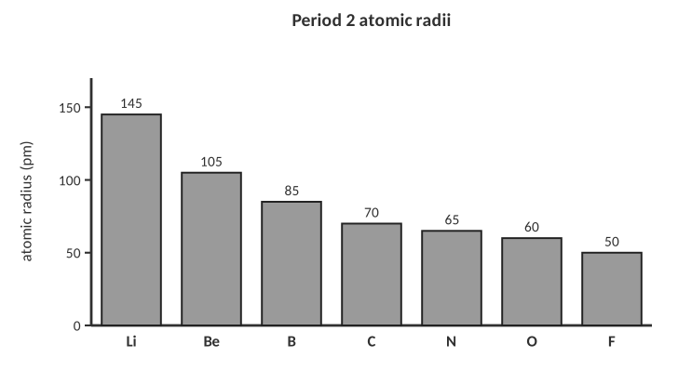
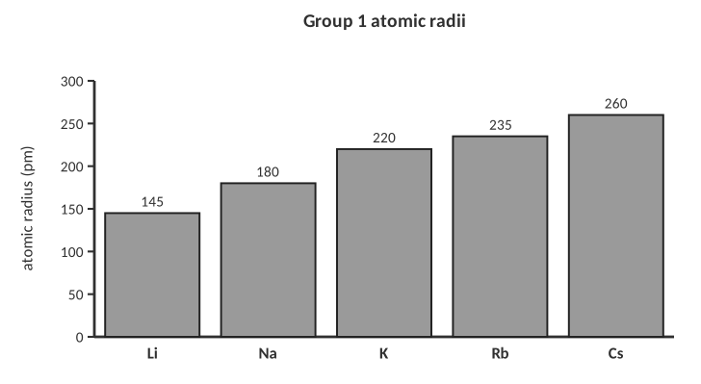
Radii shown are empirical atomic radii (pm); different sources give slightly different numbers but the same trends.
2. State the trend in atomic radius (a) across a period and (b) down a group.
(a) Decreases from left to right. (b) Increases from top to bottom.

Write a full explanation (CER)
CER FRAME
Claim: what is the trend or the answer?
Evidence: quote a fact, a number or a position on the table.
Reasoning: use nuclear charge, distance and shielding (Coulomb’s law) to explain WHY.

3. Explain why a sodium atom is larger than a chlorine atom, using principles of atomic structure and Coulomb’s law.
Both atoms have their valence electrons in the third energy level, so the distance from the nucleus is similar. Chlorine has 17 protons and sodium has 11, and the extra electrons in chlorine add very little shielding, so chlorine’s effective nuclear charge is much larger (+7 vs +1). The stronger attraction pulls chlorine’s electrons closer, so Cl has the smaller radius.

4. Explain why a potassium atom is larger than a sodium atom, using Coulomb’s law.
Potassium’s valence electron is in the fourth energy level, farther from the nucleus than sodium’s in the third. Although K has more protons, the added inner shell shields the valence electron, so the effective nuclear charge is about the same (+1). The greater distance means a weaker attraction (Coulomb’s law), so K is bigger.

Bohr models: lithium and sodium
Draw Bohr models for Li and Na. Show the correct number of electrons in each shell and circle the valence electron.
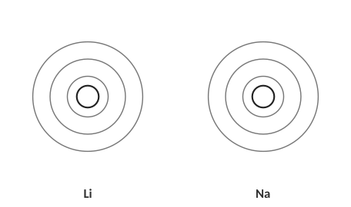
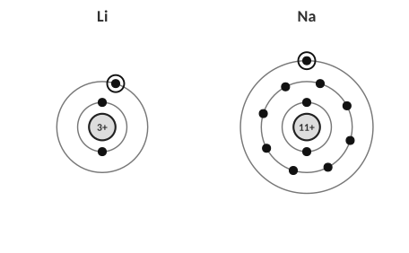
Answer: Li (2, 1) and Na (2, 8, 1).
5. Using your models, explain which atom holds its valence electron more tightly.
Lithium. Its valence electron is in shell 2, closer to the nucleus, and is shielded by only 2 core electrons. Sodium’s valence electron is in shell 3 and shielded by 10 core electrons, so it is farther away and easier to remove.

First ionization energy
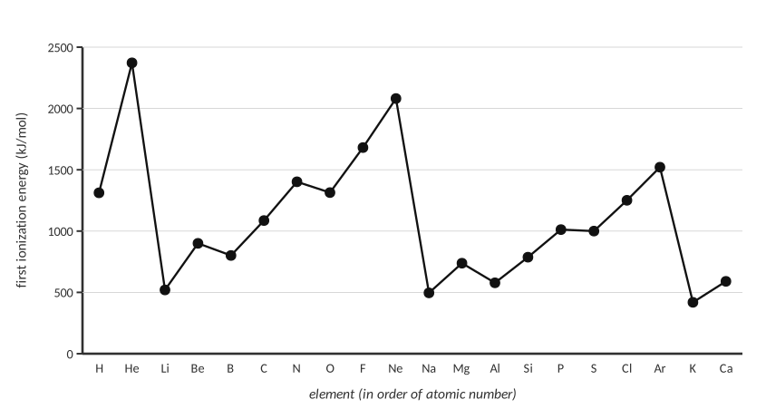
First ionization energy of elements 1–20.
6. Describe the overall pattern across a period and down a group in the graph.
Across a period the IE generally increases (peaks at the noble gases He, Ne, Ar). Down a group it decreases (He 2372 > Ne 2081 > Ar 1521; Li 520 > Na 496 > K 419). Each alkali metal is a sharp minimum.

7. Explain why the ionization energy drops sharply from neon to sodium.
Sodium’s outermost electron is in a new energy level (n = 3), much farther from the nucleus and shielded by 10 core electrons, so it is held weakly and easy to remove. Neon’s outer electrons are in n = 2, strongly held by a nuclear charge of +10 with little shielding.

8. Explain why helium has the largest first ionization energy of all the elements.
Helium’s two electrons are in the first energy level, very close to the nucleus, with no inner-electron shielding; the attraction is stronger than for any other element.

Two small exceptions
Look at the graph again: boron is slightly lower than beryllium, and oxygen is slightly lower than nitrogen. Use the configurations to explain one of them.
9. Explain why oxygen’s first IE is lower than nitrogen’s.
N is 2p³ (three unpaired electrons, one in each orbital). O is 2p⁴: one 2p orbital holds two electrons, and the repulsion between the paired electrons makes that electron easier to remove. (Beryllium vs boron: B’s outer electron is in a 2p orbital, which is higher in energy and a little farther out than 2s, and is partly shielded by the 2s electrons.)

TEACHER NOTE — IE EXCEPTIONS
These exceptions (Be>B, N>O) are not required in the homework but come up on the AP exam. Accept the general trend as correct for the unit test unless the question specifically asks about the dips.

Ranking practice
Rank from lowest to highest | Answer
First ionization energy: Li, Be, B, N, O, F | Li < B < Be < O < N < F (actual order; the trend-only answer Li < Be < B < N < O < F is accepted)
Atomic radius (smallest to largest): N, P, As, Sb, Bi, Mc | N < P < As < Sb < Bi < Mc
Atomic radius (smallest to largest): Na, Mg, Al, Si, Cl | Cl < Si < Al < Mg < Na
First ionization energy (lowest to highest): Cs, K, Na, Li | Cs < K < Na < Li

10. For each ranking above, circle the factor that matters most: nuclear charge, distance or shielding. Justify the second one in a sentence.
Down a group (N … Mc): distance/number of shells (with shielding by inner shells); radius rises. Across a period: nuclear charge (Zeff); radius falls.

11. Which atom has the largest atomic radius?
A) Mg
B) Cl
C) Al
D) Na

12. Which of these has the lowest first ionization energy?
A) Li
B) Na
C) K
D) Be

13. The main reason ionization energy increases left to right across a period is that…
A) there are more energy levels
B) effective nuclear charge increases
C) shielding increases a lot
D) atoms get larger

TOPIC  2.5 | Periodic Trends II: Electronegativity & Successive Ionization Energy  Pull in a bond • ions • families

BIG IDEA
Electronegativity tells you how strongly an atom pulls on shared electrons in a bond. Successive ionization energies tell you how many valence electrons an atom has: the jump in energy shows where the core begins.

Key vocabulary — write each definition in your own words
Term | Definition (your words) | Example / sketch
Electronegativity (EN) | A measure of how strongly an atom attracts the shared electrons in a chemical bond. (Pauling scale: F = 3.98 is the highest.) | O (3.44) pulls harder than H (2.20) in H₂O.
Successive ionization energies | The energies required to remove the 1st, 2nd, 3rd … electron from an atom, one after another. | Mg: IE₁ = 738, IE₂ = 1451 kJ/mol
Cation | A positive ion formed when an atom loses electrons. It is smaller than its atom. | Na → Na⁺
Anion | A negative ion formed when an atom gains electrons. It is larger than its atom. | Cl → Cl⁻
Isoelectronic | Having the same number of electrons (and so the same configuration). | O²⁻, F⁻, Ne, Na⁺, Mg²⁺

Electronegativity
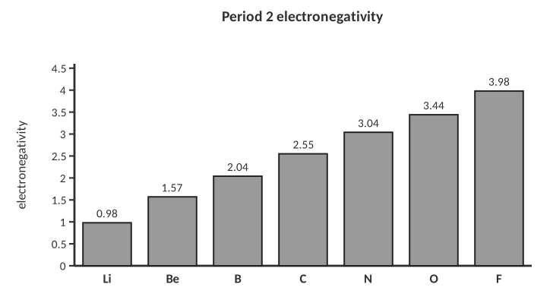
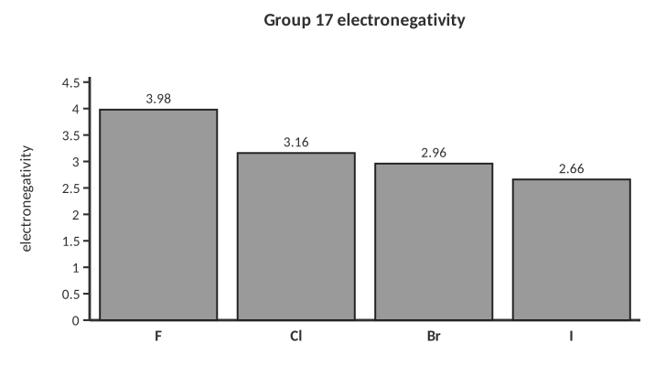
1. State the trend in electronegativity across a period and down a group. Which element is the most electronegative?
Increases left to right; decreases top to bottom. Fluorine is the most electronegative element (3.98); francium/cesium are the least.

2. Explain the trend across a period using nuclear charge, distance and shielding.
Across a period the nuclear charge increases while the shielding and number of shells stay the same. A bonding atom with a larger effective nuclear charge attracts shared electrons more strongly.

3. Why don’t the noble gases usually have electronegativity values?
They have full valence shells and rarely form bonds, so there is no shared pair to attract.

Rank (lowest to highest EN) | Answer
Na, Cl, Al, P | Na < Al < P < Cl
O, S, Se, Te | Te < Se < S < O
C, N, O, F | C < N < O < F

TEACHER NOTE — VALUES
Pauling values: Na 0.93, Al 1.61, P 2.19, Cl 3.16; Te 2.1, Se 2.55, S 2.58, O 3.44; C 2.55, N 3.04, O 3.44, F 3.98. Note Se and C are both 2.55 — rank by trend, not by memorizing.

Ionic radius: why are cations small and anions big?
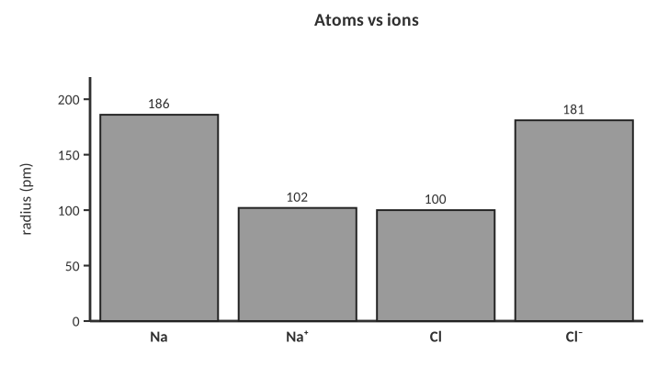
4. Explain why Na⁺ is smaller than Na and Cl⁻ is larger than Cl.
Na loses its only 3rd-shell electron, so the ion has one fewer energy level — and the same 11 protons now pull on only 10 electrons — so it shrinks a lot. Cl gains an electron into the same shell; the same 17 protons now pull on 18 electrons that repel each other more, so the electron cloud expands.

Isoelectronic series
Ion | Protons | Electrons | Configuration
N³⁻ | 7 | 10 | 1s² 2s² 2p⁶
O²⁻ | 8 | 10 | 1s² 2s² 2p⁶
F⁻ | 9 | 10 | 1s² 2s² 2p⁶
Na⁺ | 11 | 10 | 1s² 2s² 2p⁶
Mg²⁺ | 12 | 10 | 1s² 2s² 2p⁶
Al³⁺ | 13 | 10 | 1s² 2s² 2p⁶

5. Rank these six ions from largest to smallest radius and explain the pattern.
N³⁻ > O²⁻ > F⁻ > Na⁺ > Mg²⁺ > Al³⁺. All have 10 electrons in the same shells; as the number of protons increases the pull on the same 10 electrons increases, so the ion shrinks.

Successive ionization energies
THINK OF IT LIKE… PEELING LAYERS
Imagine unwrapping a gift in several layers. The outside layers come off easily, but once you reach the core of the gift it is held tightly. For an atom, the valence electrons are the easy outer layers; the core electrons are very hard to remove, so you see a huge jump in energy.

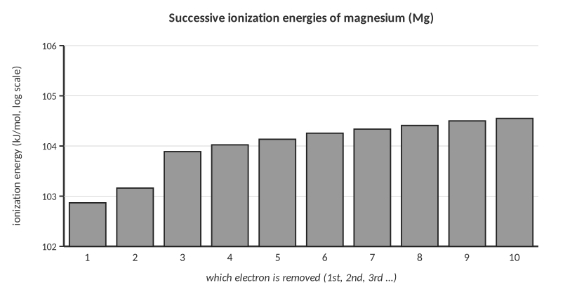
6. Where is the big jump in the Mg data, and what does it tell you about magnesium?
The big jump is between IE₂ (1451) and IE₃ (7733). Mg has two easily removed valence electrons, and the third electron comes from the core (n = 2), which is much closer to the nucleus. So Mg is in group 2.

An unknown element's successive ionization energies (kJ/mol) are:
IE₁ | IE₂ | IE₃ | IE₄ | IE₅
786 | 1577 | 3232 | 4356 | 16091

7. In which group does this element belong? Explain, and name one possible element.
The big jump comes after IE₄, so it has 4 valence electrons: group 14. This is silicon (Si).

IE₁ | IE₂ | IE₃ | IE₄ | IE₅
590 | 1145 | 4912 | 6491 | 8153

8. Repeat for this second unknown.
Big jump after IE₂ → 2 valence electrons → group 2. (This is calcium, Ca.)

Fluorine versus iodine
9. The first ionization energy of fluorine is 1681 kJ/mol and iodine is 1008 kJ/mol. Explain why fluorine’s is so much higher.
Fluorine’s outer electrons are in n = 2, much closer to the nucleus than iodine’s in n = 5. Iodine’s valence electrons are also shielded by many more inner electrons. By Coulomb’s law the pull on iodine’s outer electron is much weaker, so it is easier to remove.

Why do members of a family act alike?
10. Explain, using electron configurations, why sodium and potassium react in similar ways with water.
Both have one valence electron in an s sublevel (Na [Ne] 3s¹, K [Ar] 4s¹). They lose it easily to form +1 ions, so they react the same way. The difference is only in reaction speed (K’s electron is easier to remove).

TEACHER NOTE — FAMILIES
A very common homework question; the key is that chemical behavior is controlled by the valence electron configuration, not by size or number of protons.

Word bank review
Fill in the blanks using the word bank: decreases, increases, nuclear charge, shielding, distance, valence, core.
11. As you move left to right across a period, atomic radius ____________ because the ____________ increases while the number of energy levels stays the same.
decreases; nuclear charge

12. As you move down a group, ionization energy ____________ because the valence electrons are farther away and more ____________ by core electrons.
decreases; shielded (shielding)

13. A big jump in successive ionization energies shows you have started removing a ____________ electron.
core

14. Electronegativity ____________ from left to right across a period.
increases

15. Which species has the smallest radius?
A) Na⁺
B) Mg²⁺
C) F⁻
D) O²⁻

16. An element has IE₁ through IE₆ of 578, 1817, 2745, 11577, 14842, 18379. It is probably in group…
A) 1
B) 2
C) 13
D) 14

17. Which atom is the most electronegative?
A) O
B) N
C) Cl
D) S

PRACTICE
Extra Practice — Unit 2
Work these on your own or with a partner. Show all work.

A. Electron configurations
Element | Full configuration | Noble-gas shorthand | Valence e⁻
Li (Z = 3) | 1s² 2s¹ | [He] 2s¹ | 1
F (Z = 9) | 1s² 2s² 2p⁵ | [He] 2s² 2p⁵ | 7
Si (Z = 14) | 1s² 2s² 2p⁶ 3s² 3p² | [Ne] 3s² 3p² | 4
K (Z = 19) | 1s² 2s² 2p⁶ 3s² 3p⁶ 4s¹ | [Ar] 4s¹ | 1
Ti (Z = 22) | 1s² 2s² 2p⁶ 3s² 3p⁶ 4s² 3d² | [Ar] 4s² 3d² | 2
Ga (Z = 31) | 1s² 2s² 2p⁶ 3s² 3p⁶ 4s² 3d¹⁰ 4p¹ | [Ar] 4s² 3d¹⁰ 4p¹ | 3
Br (Z = 35) | 1s² 2s² 2p⁶ 3s² 3p⁶ 4s² 3d¹⁰ 4p⁵ | [Ar] 4s² 3d¹⁰ 4p⁵ | 7
I (Z = 53) | 1s² 2s² 2p⁶ 3s² 3p⁶ 4s² 3d¹⁰ 4p⁶ 5s² 4d¹⁰ 5p⁵ | [Kr] 5s² 4d¹⁰ 5p⁵ | 7

Ions
Ion | Configuration | Isoelectronic with
K⁺ | 1s² 2s² 2p⁶ 3s² 3p⁶ | Ar
S²⁻ | 1s² 2s² 2p⁶ 3s² 3p⁶ | Ar
Br⁻ | 1s² 2s² 2p⁶ 3s² 3p⁶ 4s² 3d¹⁰ 4p⁶ | Kr
Sr²⁺ | 1s² 2s² 2p⁶ 3s² 3p⁶ 4s² 3d¹⁰ 4p⁶ | Kr
Li⁺ | 1s² | He
P³⁻ | 1s² 2s² 2p⁶ 3s² 3p⁶ | Ar

Identify the element
Clue | Element
1s² 2s² 2p⁶ 3s² 3p³ | phosphorus (P)
[Ar] 4s² 3d¹⁰ 4p² | germanium (Ge)
[Kr] 5s² | strontium (Sr)
Period 3 element with 6 valence electrons | sulfur (S)
Halogen with the configuration ending 4p⁵ | bromine (Br)
The alkali metal with four energy levels | potassium (K)

B. Orbital diagrams
Draw the orbital diagram for each atom and write the number of unpaired electrons.
C (Z = 6): unpaired electrons = ______
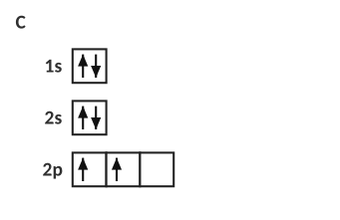
Answer: 2 unpaired
S (Z = 16): unpaired electrons = ______
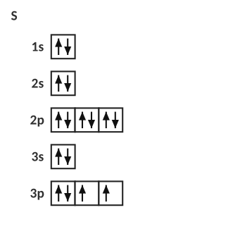
Answer: 2 unpaired
Cl (Z = 17): unpaired electrons = ______
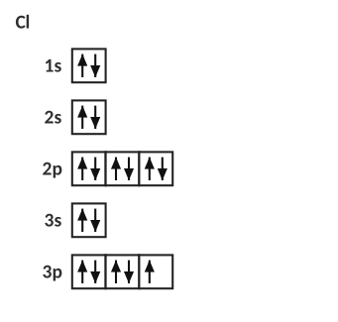
Answer: 1 unpaired
1. Atoms of which element in period 2 have the most unpaired electrons? How many?
Nitrogen, with 3 (2p³).

2. Explain, using Hund’s rule, why carbon’s two 2p electrons are in different orbitals.
Electrons in the same sublevel spread into separate orbitals with parallel spins first, because that minimizes repulsion and gives lower energy.

C. Bohr models and Lewis dot structures
Atom | Protons | Electrons per shell | Valence e⁻ | Lewis dot structure (draw)
Mg | 12 | 2, 8, 2 | 2
O | 8 | 2, 6 | 6
Ar | 18 | 2, 8, 8 | 8
B | 5 | 2, 3 | 3
Ca | 20 | 2, 8, 8, 2 | 2

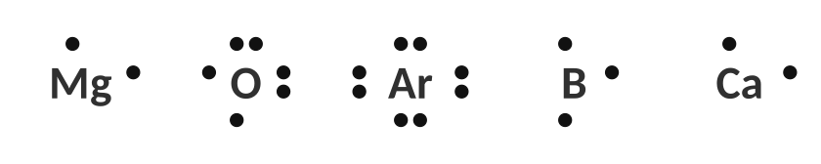
Answers: Lewis dot structures.
3. Why do elements in the same group have the same number of valence electrons? Give an example.
Elements in a group have the same outer configuration (e.g., ns²np⁵ for the halogens). F, Cl and Br all have 7 valence electrons.

D. Trends
Rank | Answer
Atomic radius, smallest to largest: S, Na, Cl, Mg | Cl < S < Mg < Na
Atomic radius, smallest to largest: Ca, Be, Mg, Sr | Be < Mg < Ca < Sr
First ionization energy, lowest to highest: Ar, Na, Mg, Cl | Na < Mg < Cl < Ar
First ionization energy, lowest to highest: Ne, Kr, He, Ar | Kr < Ar < Ne < He
Electronegativity, lowest to highest: P, Cl, Si, Na | Na < Si < P < Cl
Ion radius, smallest to largest: S²⁻, Ca²⁺, K⁺, Cl⁻ | Ca²⁺ < K⁺ < Cl⁻ < S²⁻ (all have 18 electrons)

4. For the last ranking, explain in a sentence or two why it is the order you chose.
All four ions have the same 18 electrons, so the one with the most protons (Ca²⁺, 20) pulls them in the most and is smallest; S²⁻ (16 protons) pulls the least and is largest.

5. Explain why magnesium has a higher first ionization energy than sodium. Use Coulomb’s law.
Both valence electrons are in n = 3, at about the same distance and shielded by the same 10 core electrons, but Mg has 12 protons versus 11, so its effective nuclear charge is greater (+2 vs +1). The stronger attraction makes the electron harder to remove.

6. Explain why the atomic radius of chlorine is smaller than that of sulfur.
Same number of shells, but Cl has one more proton and the added electron does not shield well, so Zeff is larger and the electrons are pulled closer.

7. Explain why the first ionization energy of lithium is higher than that of cesium.
Li’s valence electron is in n = 2, close to the nucleus and shielded by just 2 core electrons; Cs’s is in n = 6, far away and shielded by 54 core electrons. Distance and shielding both weaken the pull on Cs’s electron.

E. Data analysis
The table lists the first four ionization energies (kJ/mol) of four unknown elements, W, X, Y and Z, from period 3.
Element | IE₁ | IE₂ | IE₃ | IE₄ | Group?
W | 496 | 4562 | 6910 | 9543 | 1
X | 738 | 1451 | 7733 | 10543 | 2
Y | 578 | 1817 | 2745 | 11577 | 13
Z | 786 | 1577 | 3232 | 4356 | 14 (jump comes after IE₄ or later)

8. Complete the last column, then name each element (all are in period 3).
W = sodium, X = magnesium, Y = aluminum, Z = silicon.

9. Which element would form a +3 ion most easily? Explain using the data.
Y (aluminum): IE₁ through IE₃ are relatively small and IE₄ jumps from 2745 to 11577, so exactly 3 valence electrons are removed easily.

F. Lab corner: flame tests and line spectra
Flame test: the same metal ions are held in a flame on a wire loop; the flame colour identifies the metal.
Emission spectrum of hydrogen (bright lines on a dark background).
10. A lab student puts a salt in a flame and sees a red-orange glow. A second salt gives green. Explain at the level of electrons what is happening to produce the light.
Heat gives the electrons energy, and they jump to higher energy levels (excited state). When they fall back to lower levels they release the energy as light. The size of the energy gap sets the colour. Different metals have different energy gaps, so each gives its own colour.

11. Why does hydrogen give lines rather than a continuous rainbow?
The energy levels are quantized, so only particular energy differences (and therefore particular colours) are possible.

12. The student wants to identify an unknown metal. Explain why a flame test or a line spectrum is better evidence than colour of the solid.
Emission patterns are unique to each element, like a fingerprint, while many solids are white or look similar.

[ IMAGE GOES HERE ]
Add AP or homework figure: periodic table or Bohr diagram

G. Quick checks (multiple choice)
13. Which electron configuration represents an excited state of neon?
A) 1s² 2s² 2p⁶
B) 1s² 2s² 2p⁵ 3s¹
C) 1s² 2s² 2p⁶ 3s¹
D) 1s² 2s² 2p⁴

14. Which of the following has the same electron configuration as an Ar atom?
A) Na⁺
B) Cl⁻
C) F⁻
D) Mg²⁺

15. The ion with the largest radius is
A) Mg²⁺
B) Na⁺
C) F⁻
D) O²⁻

16. Which sublevel is filled right after 4s?
A) 4p
B) 3d
C) 4d
D) 5s

17. Which element has the highest first ionization energy?
A) Na
B) Mg
C) Al
D) Cl

TOPIC  ★ | Unit 2 Review  Put it in your own words before the test

1. In three or more sentences, explain how Bohr’s model improved on Rutherford’s and what evidence supports energy levels.
Bohr placed electrons in fixed energy levels instead of anywhere; electrons gain or lose energy only when they jump between levels. Line spectra and flame tests are evidence: atoms emit only specific colours.

2. What do the three rules (Aufbau, Pauli, Hund) say, and how do they work together to build an orbital diagram?
Aufbau: lowest energy first. Pauli: max 2 electrons per orbital, opposite spin. Hund: singly occupy orbitals of a sublevel before pairing.

3. Describe the three factors in Coulomb’s law that explain periodic trends and tell how each one changes across a period and down a group.
Nuclear charge: increases across, increases down (but more shells too). Distance: unchanged across, increases down. Shielding: little change across, increases down. Across a period nuclear charge dominates (radius down, IE up). Down a group distance and shielding dominate (radius up, IE down).

4. Explain how successive ionization energy data identify an element’s group.
Look for the big jump; the number of electrons removed before it equals the number of valence electrons (the group's valence count).

Draw a periodic table sketch and label the trends
Arrows: radius ↓ across, ↑ down; IE and EN ↑ across, ↓ down. Most extreme: francium largest radius, fluorine most electronegative, helium highest IE.

Sources & further reading
• Science Education Research – “Hund’s rule is like strangers getting on a bus” (analogy) — https://science-education-research.com/?p=50751
• LibreTexts – Analysis of Periodic Trends — https://chem.libretexts.org/Courses/Saint_Marys_College_Notre_Dame_IN/CHEM₃₄₂%3A_Bio-inorganic_Chemistry/Readings/Week₁%3A_Analysis_of_Periodic_Trends
• Chemistry Student – AP Chemistry periodic trends — https://chemistrystudent.com/ap-chemistry/1-atomic-structure/periodic-trends.html
• Save My Exams – AP Chem 1.7 Periodic Trends — https://www.savemyexams.co.uk/ap/chemistry/college-board/22/revision-notes/unit-1-atomic-structure-and-properties/1-7-periodic-trends/periodic-trends/
• Albert.io – Coulomb’s law review for AP Chemistry — https://www.albert.io/blog/coulombs-law-review-ap-chemistry-crash-course/

